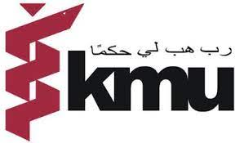
KHYBER MEDICAL UNIVERSITY
OFFICE OF RESEARCH INNOVATION AND COMMERCIALIZATION
OPPORTUNITY
Office of Research Innovation and Commercialization (ORIC), Khyber Medical University needs Research Assistants for conducting office and field work in a donor funded project. Interested candidates (male/female) are invited to apply for the following position purely on contract basis.
S. No | Name of the position | Place of Duty | Last date of apply
1 | Research Assistants | Multiple Districts i.e., Chitral, Peshawar, Malakand and Kohat Districts | 8th October 2021
Note:
- Interested Candidates should email their CV to projectsoric@gmail.com
- Only shortlisted candidates will be notified through email and called for interview.
- The candidates should bring their CVs with all other documents including educational documents and relevant experience at the time of interview
- Preference will be given to the local of the areas (place of duty).
- Same numbers of seats are allocated for each district.
- Candidates applying after last date will not be entertained.
- The competent authority reserve the right to increase or decrease the vacancies without assigning the reasons
Dr. Zohaib Khan
Project Director
Khyber Medical University
Phase-V, Hayatabad Peshawar

