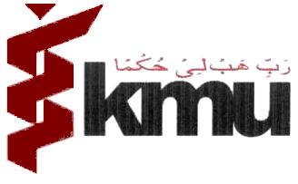

Khyber Medical University Peshawar

COMMITTED TO EXCELLENCE IN ACADEMICS & RESEARCH

ANNOUNCEMENT
for

SEED GRANT FOR NEWLY APPOINTED PHD FACULTY KMU

INTRODUCTION:

Applications are invited from newly appointed PhD faculty of KMU to compete for the SEED Grants. Applications, along with the required documents, may be submitted to the ORIC office on the prescribed form before 19th July, 2024
A maximum of 0.5 million PKR will be awarded as individual grants and collaborative projects.
Detailed TORs and other necessary documents including proposal and budget templates can be obtained from the ORIC KMU or can be downloaded from oric.kmu.edu.pk

Note:
All applications shall be endorsed by the relevant HOD/Director.
ORIC-KMU
Khyber Medical University
Phase-V, Hayatabad Peshawar,
oric.kmu.edu.pk
Phone: 091-9217258

